Sixth Form Home-School Agreement

Aims and Ethos

Surbiton High School aims to bring out the best in everyone: to discover the best in everyone, to expect the best from everyone, and to support everyone to achieve their personal best. Our school motto "May love always lead us" encourages respect for and service to others.
Surbiton High School is a friendly and vibrant community where individuals thrive and feel happy, secure, confident and valued. Our approach combines an intellectually rigorous and challenging academic environment with outstanding pastoral care and support.

We create this ethos and achieve these aims by:

- Providing a broad, balanced, challenging and enriching educational experience for all pupils
- Nurturing the growth of intellectual curiosity, creativity and independent learning
- Creating opportunities for leadership and challenge
- Fostering a lifelong love of learning
- Ensuring relationships are based on mutual respect
- Encouraging hard work and commitment
- Offering a wide range of extra-curricular activities and enrichment programmes
- Working in partnership with parents; encouraging them to be actively involved in their child's education
- Preparing pupils for their subsequent education and their future lives
- Celebrating success and achievement

As a student at Surbiton High School, I will:
- Be a role model for younger students.  - Bring resources to lessons as necessary.  - Strive to achieve the highest academic standards of which I am capable.  - Work my hardest to gain grades which will allow me to progress on to Year 13 and be successful at A2.  - Recognise that study in the Sixth Form is a full-time occupation.  - Attend all lessons, tutor periods, assemblies and registrations.  - Arrive punctually to all lessons, tutor periods, assemblies and registrations.  - Meet all homework and coursework deadlines.  - Use study periods productively, take responsibility for my own learning.  - Ensure work set for cover lessons is completed ahead of the next lesson in that subject.  - Take an active part in the co-curricular life of the School.  - Manage my social life and other commitments so that they don’t impede my studies. | - Treat school staff, fellow students, visitors, property and resources with respect.  - Abide by the Sixth Form dress-code.  - Not act in such a way so that I might bring the reputation of the School into disrepute.  - Respect the school site, especially the Sixth Form Common Room, and agree to respect the quiet working environment of the Sixth Form Study Area.  - Ensure work set for cover lessons is completed ahead of the next lesson in that subject.  - Keep paid work to a minimum and always prioritise school work and events.  - Follow agreed procedures to report any absence.  - Not take holidays during term time without the prior permission of the Director of Sixth Form.  - Return all school-issued equipment at the end of the course.
The School: | As a parent, I will:
- Places great value on respect for one another and achieving one’s potential.  - Views the spiritual, moral, cultural and social development of the pupils as an essential part of its duty of care.  - Promotes good behaviour and discipline.  - Sets regular homework.  - Will provide a high quality learning environment.  - Aims to deliver regularly good and outstanding teaching.  - Expects high standards of student work and behaviour.  - Deals with parents' concerns as soon as possible.  - Takes action to tackle bullying when it is notified.  - Expects each student to contribute to the life of the School and to value and to use the opportunities provided.  - Provides regular assessment of work, with constructive feedback on how students’ work can be improved.  - Provides support, information, advice and guidance on Further and Higher Education and employment opportunities.  - Communicates with parents regularly on aspects of school life, including students’ progress, achievement, attendance and pastoral issues (where necessary or appropriate).  - Fosters an attitude of open-mindedness, empathy and mutual understanding.  - Provides access to a range of curricular and co-curricular activities and experiences to enrich and broaden students' education.  - Provides a tutorial system that offers advice, support and guidance. | - Support the School’s ethos, aims and ideals.  - Support the School’s policies.  - Support and encourage my daughter to achieve her potential.  - Recognise that Sixth Form study is a full-time occupation and requires a significant element of independent study.  - Support the School in the expectation that students attend all lessons, tutor periods, assemblies and registrations.  - Maintain close communication with the School on aspects that could affect my daughter’s progress, including attendance and pastoral issues.  - Follow agreed procedures to report any absence.  - Provide a suitable area for home study.  - Support my/our child in homework and other opportunities for home learning.  - Encourage my daughter to keep paid work to a minimum and to always prioritise school work and events.  - Support the School by not taking my daughter on holiday during term time without the prior permission of the Director of Sixth Form.  - Support the School’s Sixth Form uniform policy and understand that the final decision on acceptable dress lies with the Director of Sixth Form.  - Make the School aware of any concerns or problems that might affect my daughter’s work or behaviour.  - Attend parents’ evenings and discussions about my/our daughter’s progress.

As a student in the Sixth Form, I will comply with the Sixth Form Agreement. I understand that non-compliance with the agreement may result in my place in the Sixth Form being withdrawn.

Student’s name:……………………………........... Signature: …………………................ Date:….…………

Parent’s name:……………………………............. Signature: …………………................. Date:……..………

Signed by the School:

Mrs R Glover Mr J Owen
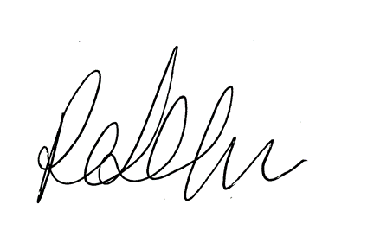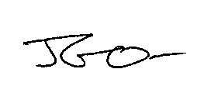
Principal Director of Sixth Form

